Concept 1: Making an accessible method of learning more about recent scam trends (podcasts, articles, etc)

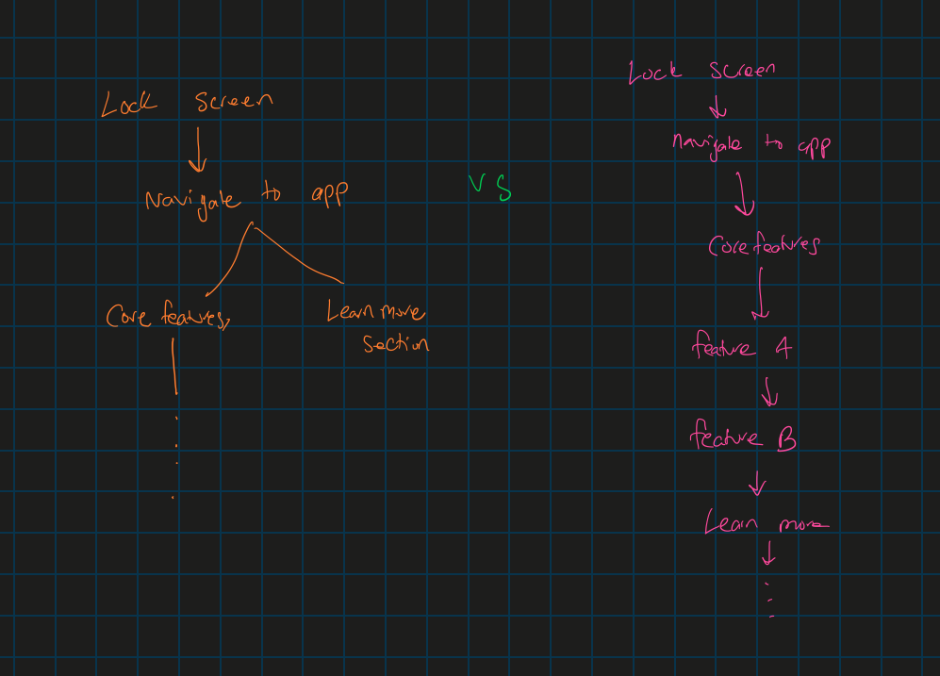

Describes an example of how an application flows. In modern UI’s, there are methods to access various pages from many avenues. This tree diagram is showing a comparison between spreading out different methods of accessing pages vs having everything in more flow.

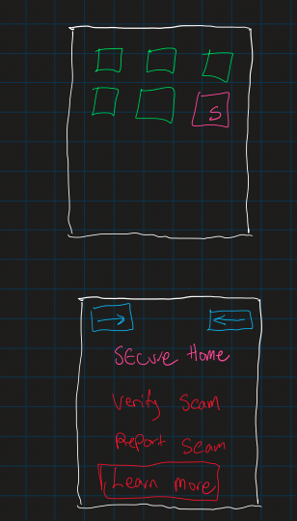load to the front page and we can see all options that are accessible. Here we will focus on the Learn more tab as this concept covers context 1.

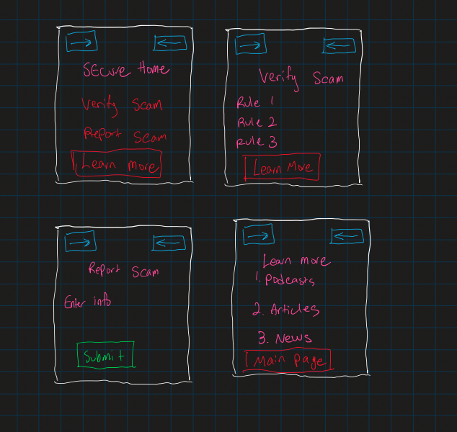

The key concept is that we can navigate to a relevant page right away rather than clicking back (working back up the page tree mentioned at the start) to get to certain pages. The idea is that we want pages accessible for relevant scenarios. Ie) what if the user wants to verify if a call is indeed a scam call, then they may also want to know about new scams, etc.

Advantages:

1. Easy to access different pages according to current pages
2. Saves time for users, especially high stress situations
3. Promotes learning throughout as users may neglect this feature (knowledge is key)
4. Easier to navigate and seamless

Disadvantages:

1. Page may become too cluttered
2. Might create a weird cycle or loop of pages
3. Navigation may become confusing if setup is not clear
4. If we extend our program to add more features, then we have trouble deciding what pages should be linked next